NAME : WIJAYAWARDHANA W.A.H.A.

REGISTRATION NO. : 2019/E/166

SEMESTER : SEMESTER 04

DATE ASSIGNED : 08 MARCH 2022

EXCERCISE

EC 4070

DATA STRUCTURES AND ALGORITHMS

01.

Code:-

import java.util.Scanner;

public class Fibonacci {

static void fibonacci(int n)

{

int total = 0;

int n1 = 1;

int n2 = 1;

for(int i =0; i<n;i++)

{

if(i <2)

{

total = n1;

}

else

{

total = n1+n2;

n1=n2;

n2=total;

}

System.out.print(total + " ");

}

}

public static void main(String[] args) {

Scanner scanner = new Scanner(System.in);

System.out.print("Enter number how many numbers need : ");

int number = scanner.nextInt();

fibonacci(number);

}

}

Outputs:-

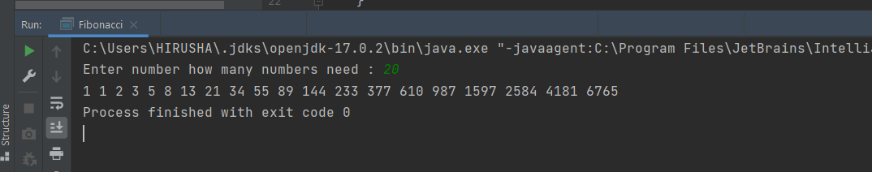

02.

Code:

public class CountOccurrences {

static void countCharactersInString(String word)

{

char[] characters = new char[word.length()];

for(int i =0; i<word.length();i++)

{

characters[i] = word.charAt(i);

}

for(int j =0; j <characters.length; j++)

{

int n = 1;

for(int k = j+1; k < characters.length; k++)

{

if(characters[j] == characters[k])

{

n++;

}

}

System.out.print(characters[j] +" = "+ n +" ");

}

}

public static void main(String[] args) {

countCharactersInString("JAVAHUNGRY");

}

}

Output:-

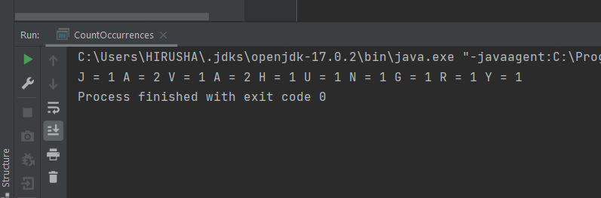

03.

Code:-

public class FindCommonElements {

static void searchCommonElements(int[] arrayOne, int[] arrayTwo)

{

System.out.print("{");

int[] equalElements = new int[5];

for(int i =0; i<arrayOne.length; i++)

{

for(int j = 0; j < arrayTwo.length; j++)

{

if(arrayOne[i] == arrayTwo[j])

{

System.out.print(arrayOne[i] + ",");

}

}

}

System.out.print("}");

}

public static void main(String[] args) {

int[] arrayOne = new int[]{23,56,34,12,67};

int[] arrayTwo = new int[]{56,78,65,34,23};

searchCommonElements(arrayOne, arrayTwo);

}

}

Output:

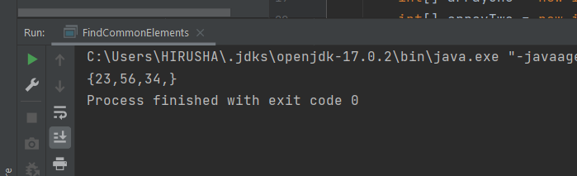

04.

Code:-

import java.util.ArrayList;

public class SearchElement {

static void searchElementsInArray(ArrayList<String> arrayList, String searchElement)

{

boolean isFound = false;

for(int i=0; i<arrayList.size();i++)

{

if(arrayList.get(i) == searchElement)

{

System.out.println(searchElement);

isFound = true;

}

}

if(isFound == false)

{

System.out.println("Element not founded.");

}

}

public static void main(String[] args) {

ArrayList<String> arrayListElement = new ArrayList<String>();

arrayListElement.add("Red");

arrayListElement.add("Green");

arrayListElement.add("Orange");

arrayListElement.add("White");

arrayListElement.add("Black");

System.out.println("For search Red : ");

searchElementsInArray(arrayListElement, "Red");

System.out.println("For search Blue : ");

searchElementsInArray(arrayListElement, "Blue");

}

}

Output:-

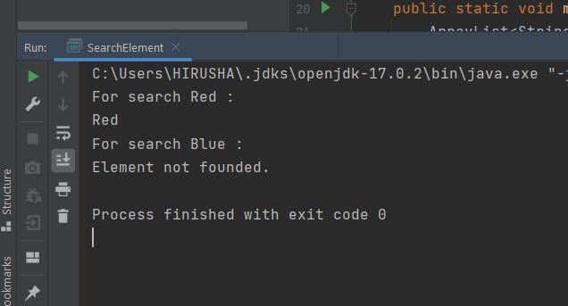

05.

Code:-

public class Circle {

private double radius; // Define radius as private variable.

private String color; // Define color as private variable.

public double area; // Define area variable.

//final double piValue = 22/7; // Define pi value as non changing value.

// Overload constructor.

public Circle()

{

radius = 2;

color = "White";

}

// Constructor build with radius and default color.

public Circle(double radius)

{

this.radius = radius;

color = "White";

}

// Constructor build with user values.

public Circle(double radius , String color)

{

this.radius = radius;

this.color = color;

}

public double getRadius()

{

return radius;

}

public String getColor()

{

return color;

}

public double getArea()

{

area = Math.PI\*radius\*radius;

return area;

}

}

Main class:

public class TestCircle {

public static void main(String[] args) {

Circle circle01 = new Circle();

System.out.println("Radius of circle : " + circle01.getRadius());

System.out.println("Color of circle : " + circle01.getColor());

System.out.println("Area of circle : " + circle01.getArea());

}

}

Output:-

